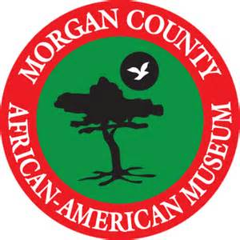Morgan County African American Museum
June Festival, Saturday, June 22, 2019
12:00 pm-5:00 pm
Vendor Application
Event date: June 22, 2019

APPLICATION DEADLINE: June 1, 2019

Vendor Fee…………………….…………………………………… $60.00
(Cash, Check or Money Order made payable to Morgan County African American Museum)

Set up: 11:00 am @156 Academy Street, Madison Open.1:00 pm-4:00 pm
Please complete information below:

Booth Participant Information

Participant/Group name: __________________________________________________________
Type of Booth: ______ food _____merchandise _____information

Contact name: __________________________________________________________________
Address: ______________________________________________________________________
City: ____________________________________ State/Zip code: ________________________
Telephone: ____________________________________________________________________
E-mail:_______________________________________________________________________
REMINDERS:
- If the event is cancelled due to severe weather or conditions beyond the control of the MCAAM, your booth fee will not be refunded.
- PLEASE PRACTICE SAFETY MEASURES AT ALL TIMES.
- All individual(s)/organizations are responsible for setting up their booths and cleaning up their area. The committee will check periodically to make sure area is clean.
- The Morgan County African American Museum WILL NOT be responsible for any losses, materials, or personal injuries while participating in the parade, booth rental, or any activities during the festivities.
- Certification of signature below agrees with above statements

________________________________________ __________________________
Signature Date

________________________________________ __________________________
Please Print Name Here Date

Please return application to: Contact List:
Morgan County African American Museum Office: 706 342-9191
156 Academy Street, P.O. Box 482 Cheryl Bland (mobile) 706 318-1718
Madison, GA 30650 directormcaam@yahoo.com

